

**Signals and Systems**

Lab Report #09

# Name:

Taha Saeed

**Registration number:**

FA18-EEE-032

**Submitted to:**

Dr. Ghufran Shafiq

**In-Lab Tasks**

**Task 01: The periodic signal is defined in one period as . Plot in time of four periods the approximate signals using 81 terms of complex exponential form of Fourier series.**

**Solution:**

clear all;

clc;

T=6;

t0=0;

t1=6;

w=(2*pi)/T;

syms t;

X=t.*exp(-t);

subplot(3,1,1);

ezplot(X,[t0,t1]);

title('original signal');

t3=t0:0.01:t1;

X1=t3.*exp(-t3);

X4=repmat(X1,1,4);

t4=linspace(t0,4*t1,length(X4));

subplot(3,1,2);

plot(t4,X4);

title('original signal over 4 time periods');

for k=-40:40

E(k+41)=exp(1i*k*w*t);

end

for k=-40:40

ak(k+41)=(1/T).*int(X.*exp(-1i*k*w*t),t,t0,t);

end

final=sum(ak.*E);

subplot(3,1,3);

ezplot(final,[t0,4*t1]);

title('fourier series of signal');

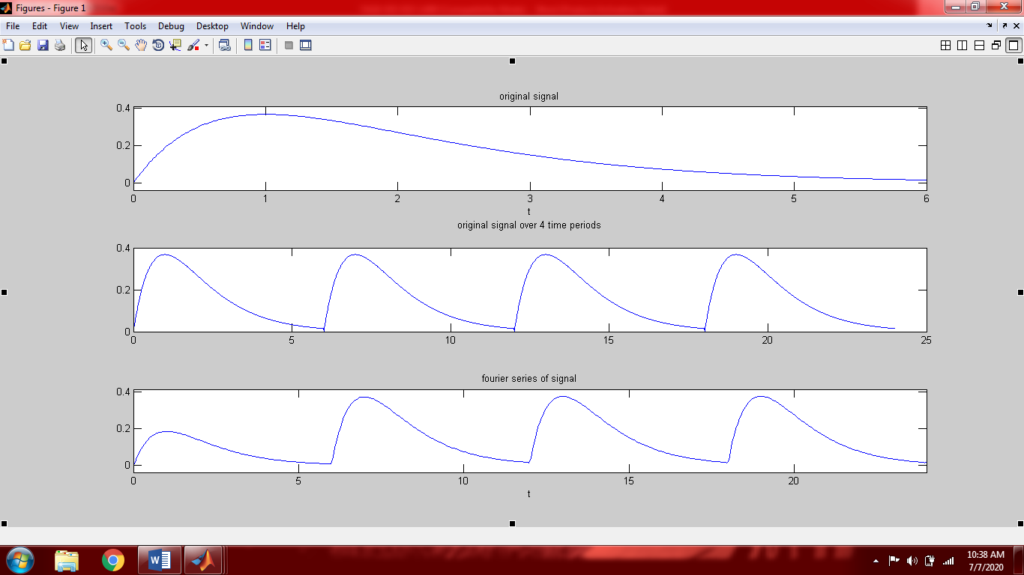

**Task 02: Plot the coefficients of the complex exponential Fourier series for the periodic signal that in one period is defined by .**

**Solution:**

clear all;

clc;

T=6;

w=(2*pi)/T;

t1=-3;

t2=+3;

syms t

X=exp(-t.^2);

subplot(3,1,1);

ezplot(X,[t1,t2]);

title('original signal');

for k=-3:3

ak(k+4)=(1/T).*int(X.*exp(-1i*k*w*t),t,t1,t2);

end

%another method to find fourier series coefficients is as follow in comment

%syms t k;

%bk=(1/T).*int(X.*exp(-1i*k*w*t),t,t1,t2);

%k1=-3:3;

%ak=subs(bk,k,k1);

k1=[-3:3];

subplot(3,1,2);

stem(k1,ak);

title('ak');

Y=double(ak);

subplot(3,1,3);

stem(k1,angle(Y));

title('phase of ak');

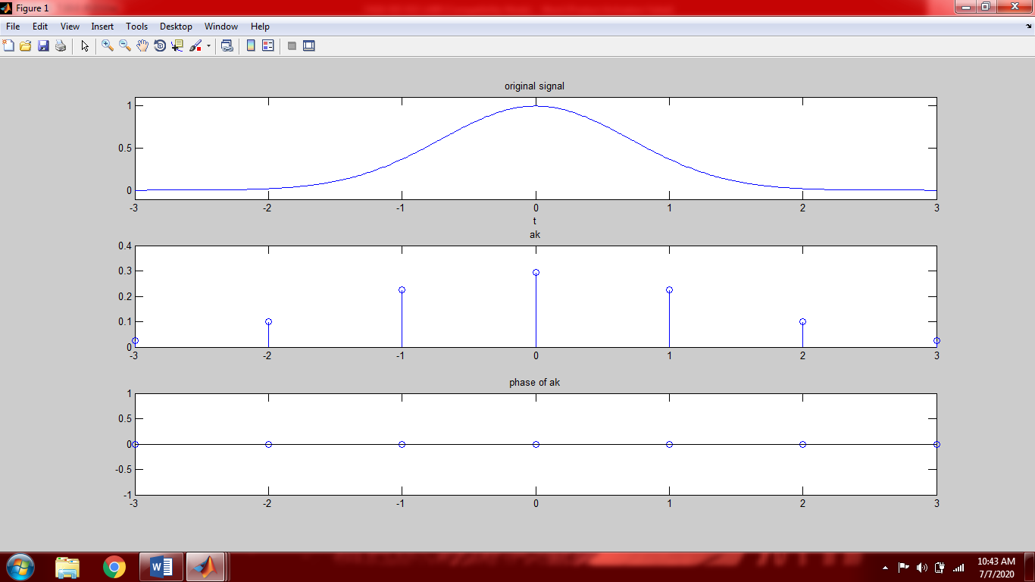

**Task 03: The periodic signal in a period is given by**



**Plot in one period the approximate signals using 41 and 201 term of the complex exponential Fourier series. Furthermore, each time plot the complex exponential coefficients**.

**Solution:**

clear all;

clc;

T=2;

w=(2*pi)/T;

t1=0;

t2=2;

syms t

X=heaviside(t)-heaviside(t-1);

figure(1)

subplot(3,1,1);

ezplot(X,[-1,3]);

title('original signal');

for k=-20:20

E(k+21)=exp(1i*k*w*t);

end

for k=-20:20

ak(k+21)=(1/T).*int(X.*exp(-1i*k*w*t),t,t1,t2);

end

final1=sum(ak.*E);

subplot(3,1,2);

ezplot(final1,[-1,3]);

title('using 41 terms');

for k=-100:100

P(k+101)=exp(1i*k*w*t);

end

for k=-100:100

Ak(k+101)=(1/T).*int(X.*exp(-1i*k*w*t),t,t1,t2);

end

final2=sum(Ak.*P);

subplot(3,1,3);

ezplot(final2,[-1,3]);

title('using 201 terms');

figure(2)

subplot(2,1,1);

k1=-20:20;

stem(k1,abs(ak));

title('|ak| 41 terms');

r=double(ak);

subplot(2,1,2);

stem(k1,angle(r));

title('angle of ak');

figure(3)

subplot(2,1,1);

k2=-100:100;

stem(k2,abs(Ak));

title('|ak| 201 terms');

r1=double(Ak);

subplot(2,1,2);

stem(k2,angle(r1));

title('angle of ak');

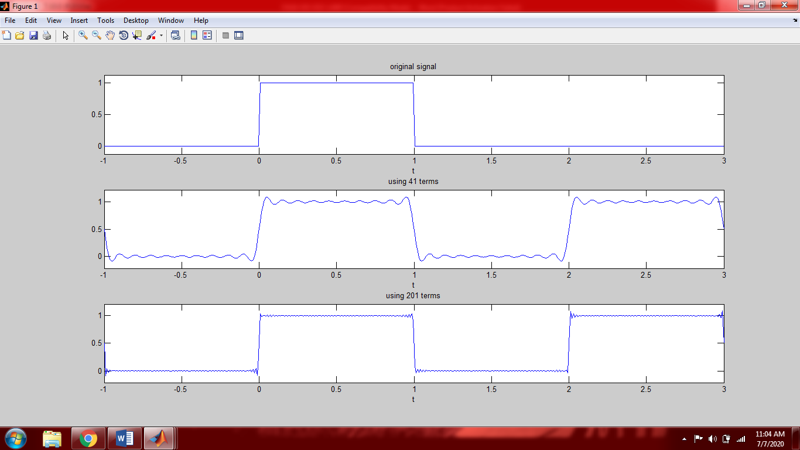

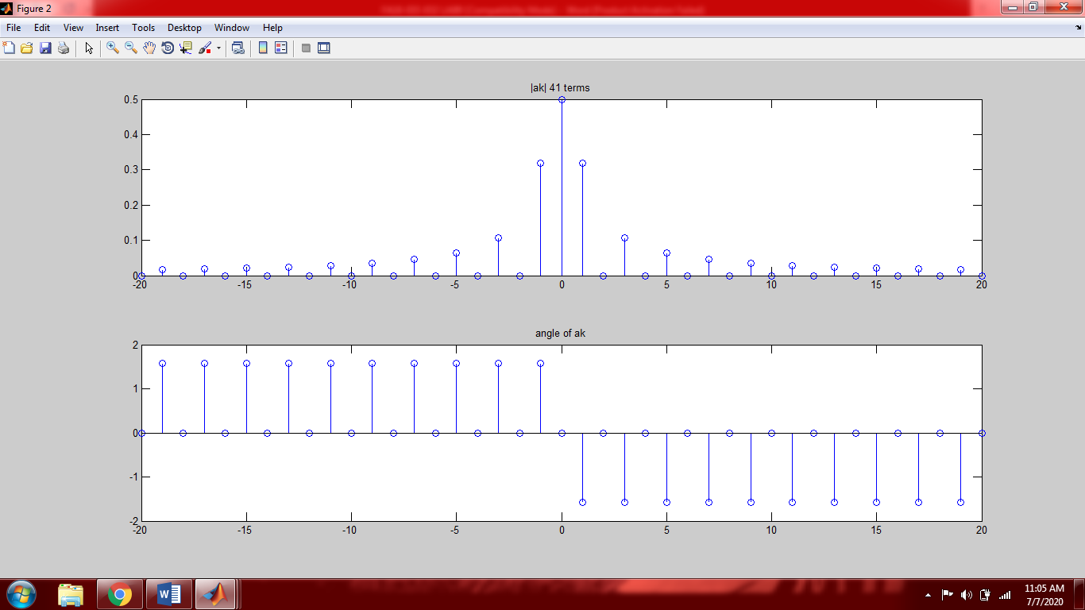

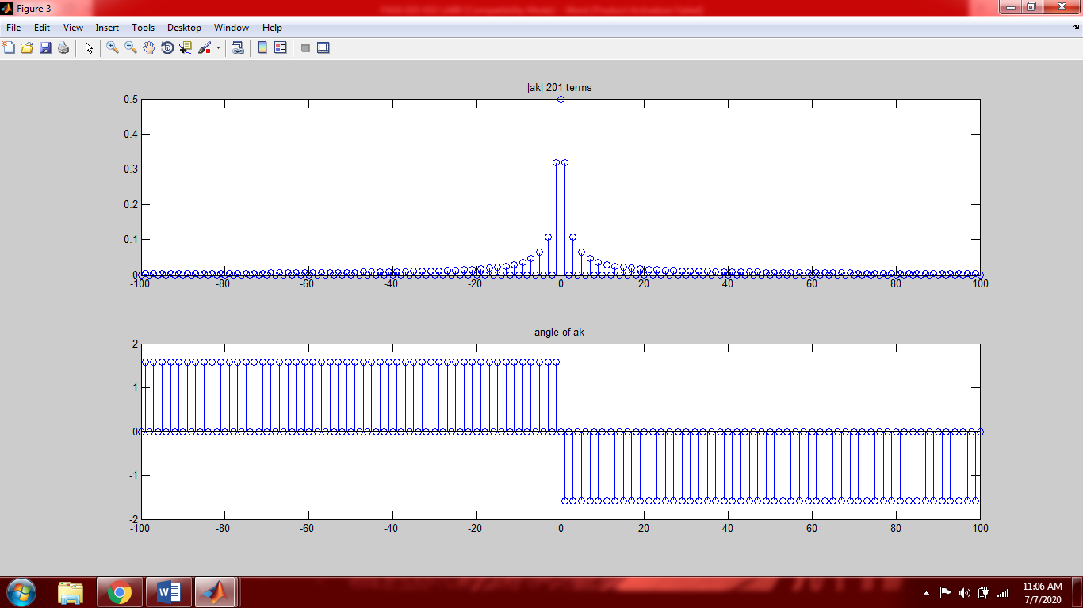

**Result:**

As can be seen from the graphs that by increasing the number of Fourier series coefficients the approximated signal becomes more and more equal (similar) to the original signal

**Task 04: The periodic signal in a period is given by**



**Calculate the approximation percentage when the signal is approximated by 3, 5, 7, and 17 terms of the complex exponential Fourier series. Furthermore, plot the signal in each case.**

**Solution:**

clear all;

clc;

T=2;

w=(2*pi)/T;

t1=0;

t2=2;

syms t

X=(heaviside(t)-heaviside(t-1))+(2-t)*(heaviside(t-1)-heaviside(t-2));

figure(1)

ezplot(X,[-1,3]);

title('original signal');

Energy=int(abs(X).^2,t,t1,t2);

for k=-1:1

E(k+2)=exp(1i*k*w*t);

end

for k=-1:1

ak(k+2)=(1/T).*int(X.*exp(-1i*k*w*t),t,t1,t2);

end

final=sum(ak.*E);

figure(2)

subplot(2,2,1);

ezplot(final,[-1,3]);

title('by using 3 coefficients');

Energy2=int(abs(final).^2,t,t1,t2);

perror1=(abs(Energy-Energy2))/Energy;

perror1=double(perror1)*100;

Approximation1=100-perror1

for k=-2:2

E(k+3)=exp(1i*k*w*t);

end

for k=-2:2

ak(k+3)=(1/T).*int(X.*exp(-1i*k*w*t),t,t1,t2);

end

final=sum(ak.*E);

figure(2)

subplot(2,2,2);

ezplot(final,[-1,3]);

title('by using 5 coefficients');

Energy3=int(abs(final).^2,t,t1,t2);

perror2=(abs(Energy-Energy3))/Energy;

perror2=double(perror2)*100;

Approximation2=100-perror2

for k=-3:3

E(k+4)=exp(1i*k*w*t);

end

for k=-3:3

ak(k+4)=(1/T).*int(X.*exp(-1i*k*w*t),t,t1,t2);

end

final=sum(ak.*E);

figure(2)

subplot(2,2,3);

ezplot(final,[-1,3]);

title('by using 7 coefficients');

Energy4=int(abs(final).^2,t,t1,t2);

perror3=(abs(Energy-Energy4))/Energy;

perror3=double(perror3)*100;

Approximation3=100-perror3

for k=-8:8

E(k+9)=exp(1i*k*w*t);

end

for k=-8:8

ak(k+9)=(1/T).*int(X.*exp(-1i*k*w*t),t,t1,t2);

end

final=sum(ak.*E);

figure(2)

subplot(2,2,4);

ezplot(final,[-1,3]);

title('by using 17 coefficients');

Energy5=int(abs(final).^2,t,t1,t2);

perror4=(abs(Energy-Energy5))/Energy;

perror4=double(perror4)*100;

Approximation4=100-perror4

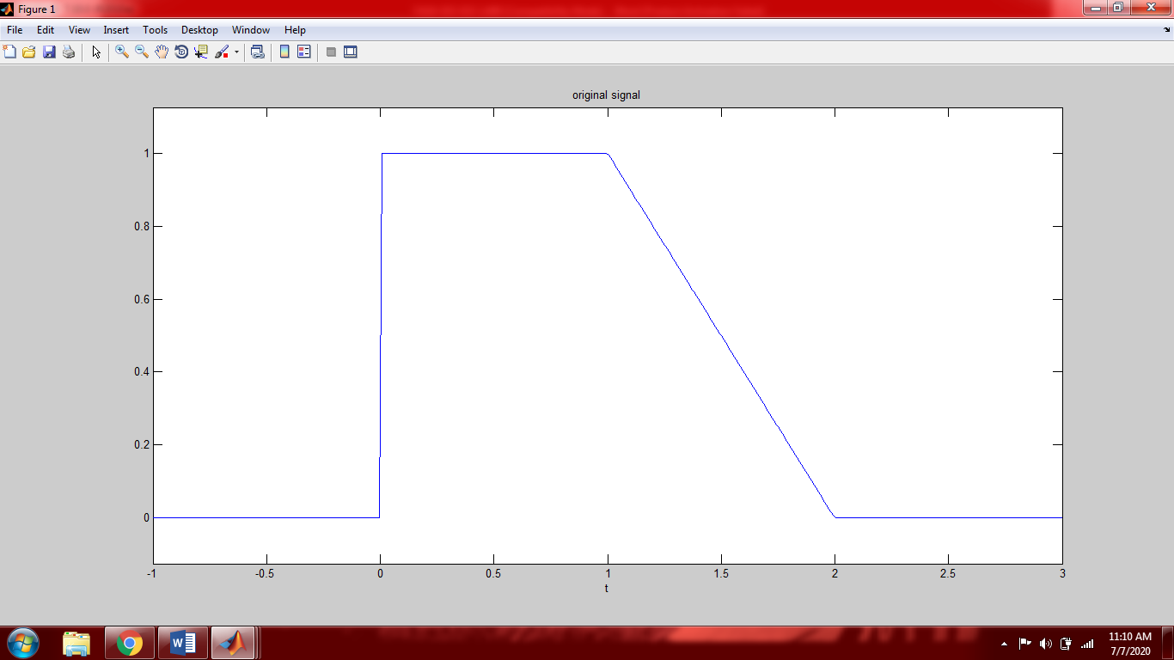

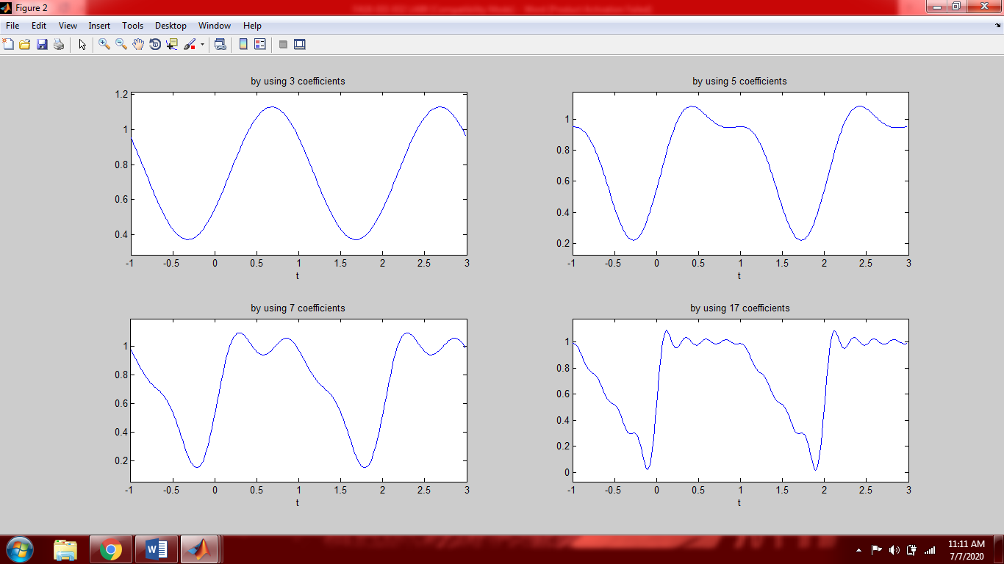

**Result:**

Approximation1 =

95.0539

Approximation2 =

96.9537

Approximation3 =

97.8360

Approximation4 =

99.1060

It can be seen from the above result that by increasing the number of Fourier series coefficients the approximated signal becomes more and more equal to original signal (more approximate to original signal).

## 

**Post-Lab Task**

## **Critical Analysis / Conclusion**

|  |
| --- |
| In this lab we proved that a periodic signal can be represented in the form of complex Fourier series.  By increasing the number of Fourier series coefficients the signal becomes more approximate to the original signal (becomes more equal to original signal).  There are two methods of finding coefficients of complex exponential Fourier series. Both methods give same answers.   1. **Loop method:**   If you want to approximate a signal then this method is used   1. **Substitution method:**   If you want to just find the coefficients and graph them then this method is used. In this method, we find a generalized expression for the FS coefficients, and then plug in the range of desired harmonics that we want to see. This is a faster approach if the purpose is only to find and show the FS coefficients. |